How to install the C language GCC compiler on Windows

The most well know compiler for C language is the GNU compiler called **gcc**. On Linux, **gcc** is install by default and you can start to compile and execute C language code almost right away, but that is not the case on Windows.

# How to install gcc on Windows?

We will have to install a software called **MSYS2**, which is an “easy” way to give some linux feel to your Windows PC and able it to install programs almost as easily as in linux.

## Installing MSYS2 on your PC

Go to <https://www.msys2.org/> and download the installer:

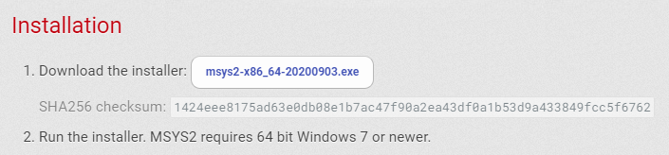

Then launch the installer with admin rights and follow the installation process using the default options.

Once you installed it, you will see 3 new programs in your list of programs:

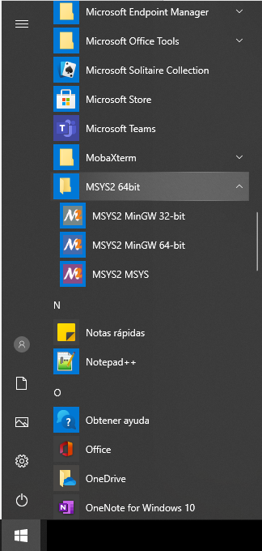

Run the 3rd one **MSYS2 MSYS** to open a special command window in which you can input commands and start to install programs:

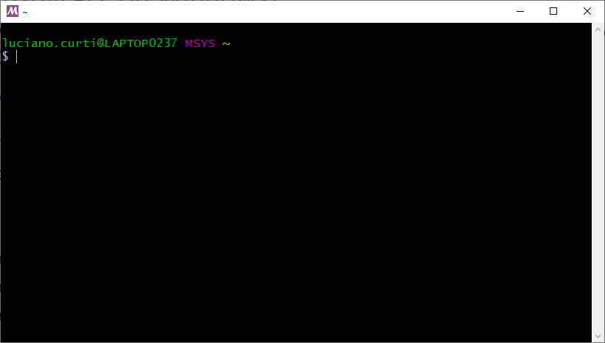

When you install MSYS2 for the first time, you have to update pacman using the following command:

|  |
| --- |
| pacman -Syu |

## Installing GCC and other development tools with the pacman package management system

Then you can start to install gcc and other developer tools using pacman like this:

|  |
| --- |
| pacman -S base-devel |
| pacman -S gcc |
| pacman -S vim |
| pacman -S cmake |

This command will install first a set of development software included in a package called **base-devel** and then it will install **gcc**, **vim** and **cmake**.

## Last Important Step: Add Executables to your Windows PATH

To access all those packages easily through the normal windows command line, you have to add the two following directories to your PATH:

* C:\msys64\mingw64\bin
* C:\msys64\usr\bin

To add anything to your PATH in Windows 10:

1. Search “Advanced System Settings” in the search bar and open it:

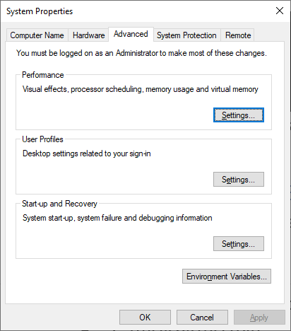

1. Open the “Environment Variables” window, click on the “Path” variable and click on “Edit”:

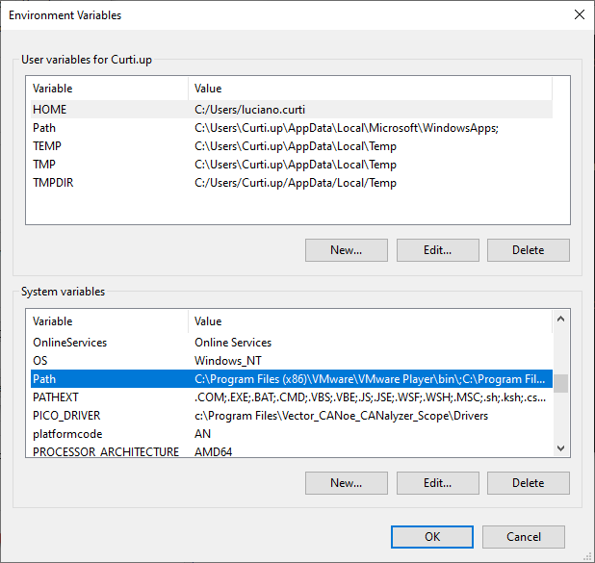

1. Click on the “New” button and add the 2 following directories to your Path:

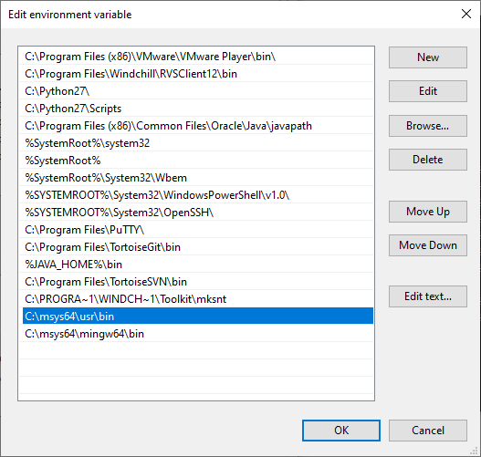

1. Click on OK on all the windows to close them.
2. Open a new Command Prompt and test that **gcc** was installed correctly by typing **gcc -v**

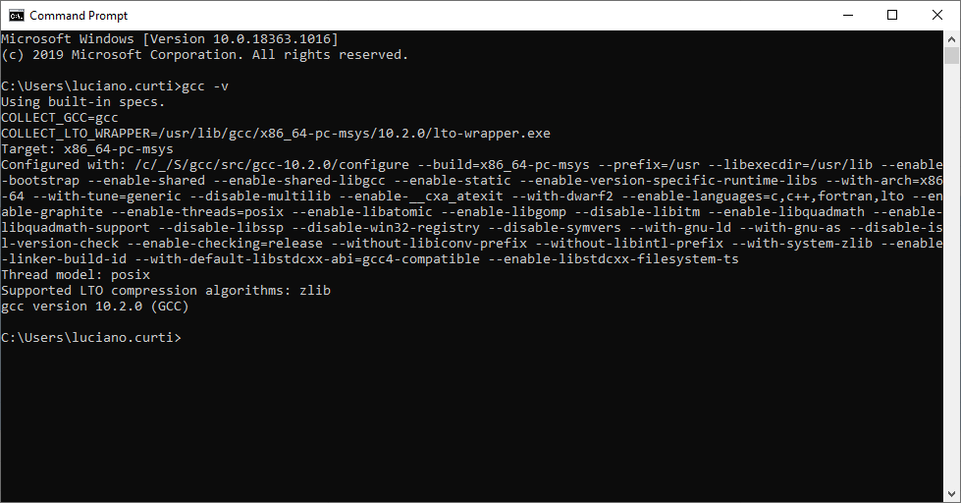

# How to use the gcc compiler?

## Step 1: Write your C code

For example, let’s take this “Hello World” example:

|  |
| --- |
| #include <stdio.h>  int main()  {      printf("Hello World \n");      return 0;  } |

Type the code in a new file and save it as **example.c**

## Step 2: Compile using gcc

By using the Command Prompt, go into the directory where your code is and write the following line:

|  |
| --- |
| >gcc example.c -o example |

This will generate an executable binary file called **example.exe** which can be used to run your code.

## Step 3: Execute your code

Finally, run the executable by writing **example.exe**

